PROPOSAL
Aprial 11, 2026

MedAI Cabinet

An Intelligent Vision System for Home Medication Safety

Prepared by:
Team: Tu Nhan Tay
Truong Duc Qui
Ngo Tuan Khoi
Nguyen Duy Toan
Nguyen Dang Gia Dao


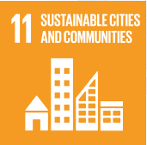


NEO League Season 2 – Innovation Humanity Challenge
Proposal Round – Technical Contribution to the UN SDGs
Content
1. Executive Summary 3
2. Problem Definition & SDG Alignment 3
2.1. The Core Problems 3
2.2. SDG Alignment 4
3. Innovation & Creativity 4
4. Technical Feasibility & IoT Relevance 5
4.1. Hardware Architecture 5
4.2. Concept Of Operation 6
4.3. Software & AI Feasibility 7
5. Impact & Viability 8
5.1. Social & Economic Impact 8
5.2. Scalability & Cost 9
6. Implementation Plan 10

1. Executive Summary
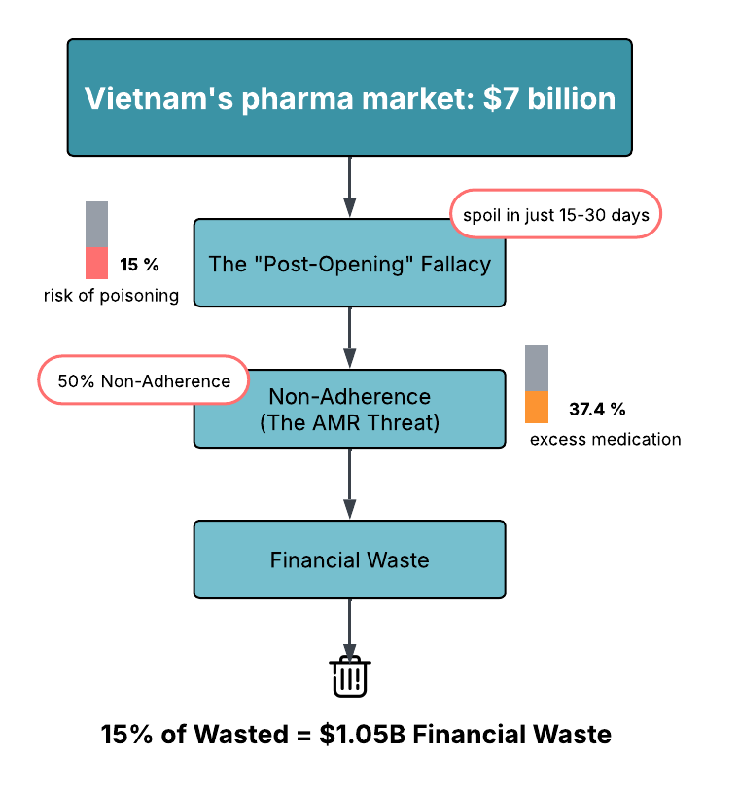
To combat a 50% medication non-adherence rate fueling the AMR crisis and Vietnam's $1.05 billion pharmaceutical waste, we introduce MedAI Cabinet. Moving beyond failed passive alarms, our AIoT ecosystem uses Visual Action Verification and Edge AI to actively ensure exact medication intake, predict post-opening expiration, and safely triage symptoms. Operating on a HaaS model, we advance SDGs 3, 11, and 13 by enforcing adherence, eliminating fatal errors, and cutting medical waste at the source.

2. Problem Definition & SDG Alignment

2.1. The Core Problems
$1.05B Financial Waste
- 15% of Vietnam's pharma market is wasted due to poor home storage and expired drugs.
50% Non-Adherence (The AMR Threat)
- Patients stopping early fuels the Superbug (AMR) epidemic — projected to cause 10M deaths/year by 2050.
The "Post-Opening" Fallacy
- Syrups & eye drops spoil in just 15-30 days post-opening, causing 15% of elderly poisoning cases.

Figure 1: The Core Problem

2.2. SDG Alignment
- [SDG 3] Good Health & Well-being: Enforces strict treatment adherence to halt Antimicrobial Resistance (AMR) and prevents fatalities from degraded medications.
- [SDG 11] Sustainable Cities & Communities: Transforms standard households into "Resilient Care Nodes." By enabling safe independent aging, it fosters inclusive urban environments and reduces the burden on city emergency infrastructure.
- [SDG 13] Climate Action: Eliminates the massive carbon footprint of $1.05B in wasted production and cuts toxic CO2/Dioxin emissions from mandatory medical waste incineration.
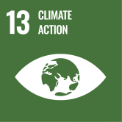



3. Innovation & Creativity
The Smart AI Pillbox transforms the passive medicine cabinet into an active "Digital Health Butler," revolutionizing medication habits through four key innovations:
- Smart Micro-Inventory: Automatically tracks pill stock and usage, shifting from static storage to dynamic home logistics.
- Dynamic Expiry & Physical Safety: Calculates real-time shelf life using environmental sensors and physically locks compartments to prevent dispensing spoiled pills.
- AI Consumption Loop: Recommends on-hand medicines for mild symptoms, prioritizing near-expiry pills to eliminate waste and the "buy new, discard old" habit.
- Zero-Friction Access: Replaces manual sorting with automated, precise dispensing. Combines low-cost hardware with Cloud sync for affordable, remote caregiver monitoring.

4. Technical Feasibility & IoT Relevance

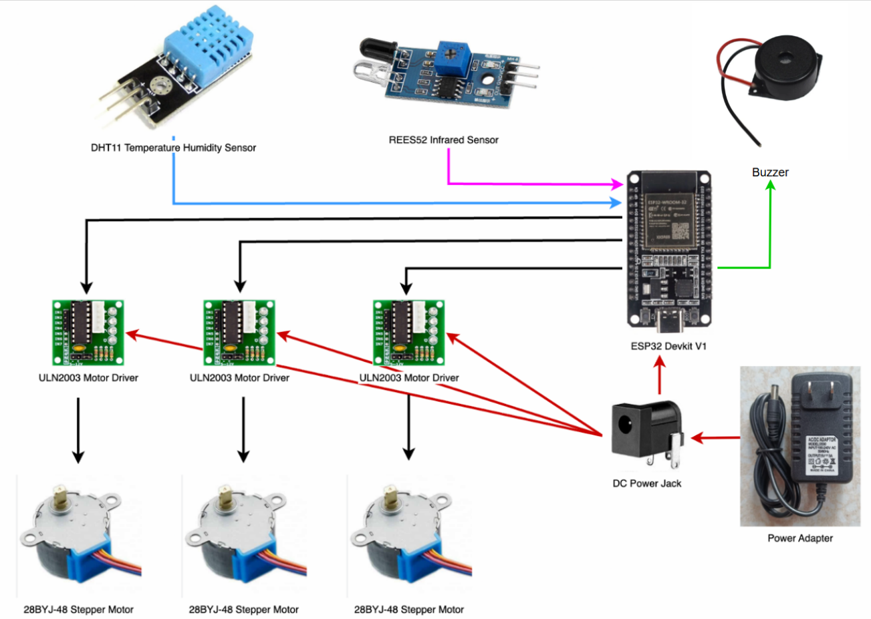
4.1. Hardware Architecture
Figure 2: Hardware Architecture
- 1 x ESP32 Devkit V1: Main MCU utilizing Wi-Fi/MQTT for Cloud/AI integration and offline logic.
- 3 x Stepper Motors + 3D parts: Controls the precise mechanical release for up to 3 different pill types.
- 1 x REES52 Infrared Sensor: Monitor pill dispensing, confirm the actual number of dispensed pill.
- 1 x DHT11 Temp Sensor: Tracks internal conditions and triggers real-time safety alerts.
- 3 x ULN2003 Motor Drivers: Ensures stable power regulation for the mechanical actuators.
- Buzzer + Casing: Provides audio alerts and protective housing for the system components.

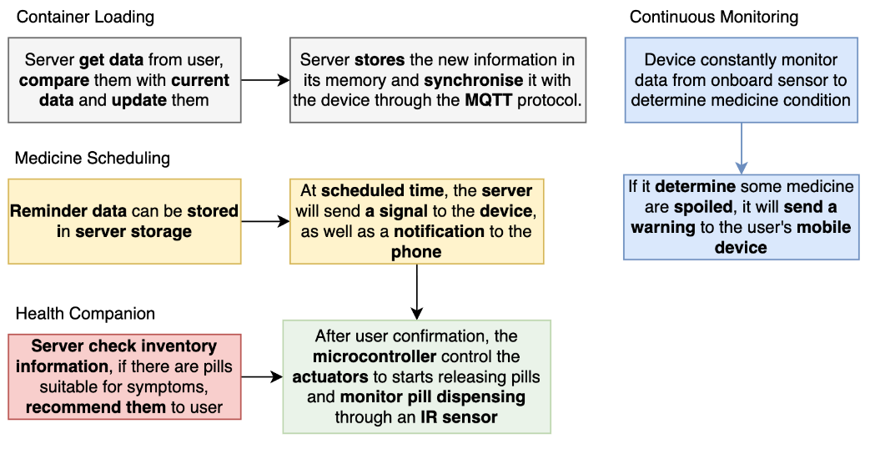
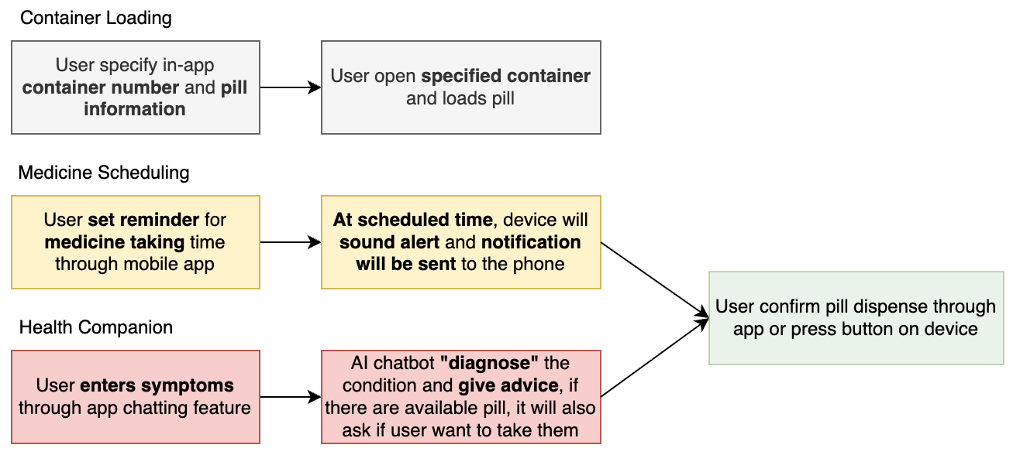
4.2. Concept Of Operation
Figure 3: User Interaction Workflow & Underlying machine operations

- The system seamlessly syncs user schedules and AI-driven health advice with the physical dispenser via MQTT.
- Continuous environmental monitoring and mandatory user confirmations guarantee safe, accurate medication delivery.

4.3. Software & AI Feasibility
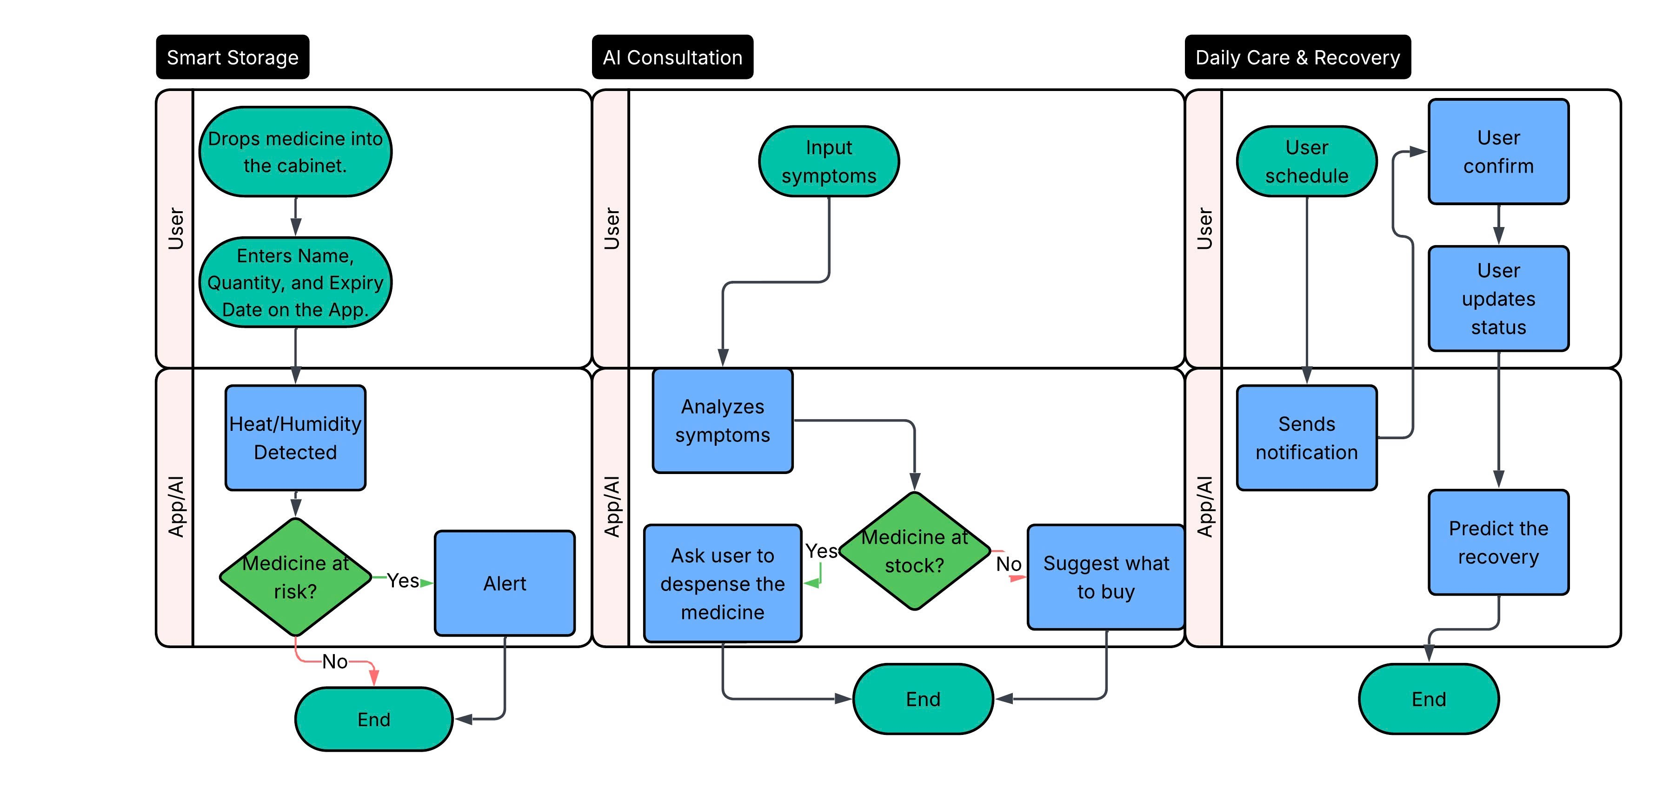
Figure 4: Software Workflow

5. Impact & Viability

5.1. Social & Economic Impact
Beneficiary / Area | The Challenge | MedAI Cabinet Solution & Impact
End-Users (Elderly & Chronic) | Poor adherence (25% baseline) & accidental poisoning. | Provides an automated fail-safe system. Maximizes adherence and eliminates the 15% poisoning risk from degraded medicines.
Caregivers (Buyers) | High mental load & financial burden of emergency care. | Delivers remote "peace of mind" via real-time intake alerts, drastically reducing preventable ER visits.
Preventative Users (Wealthy) | Supplement degradation & duplicate purchases. | Acts as a "Personal Health Butler" that protects expensive supplements from moisture and optimizes home inventory.
Global Health (SDG 3) | The Antimicrobial Resistance (AMR) crisis. | AI-enforced reminders ensure full antibiotic regimens, neutralizing the root cause of 37.4% of surplus drugs and superbug mutations.
Economy & Climate (SDGs 13) | $1.05B waste & toxic medical incineration. | AI triage prioritizes soon-to-expire meds, cutting the 15% national waste rate and reducing secondary GHG/Dioxin emissions.

5.2. Scalability & Cost
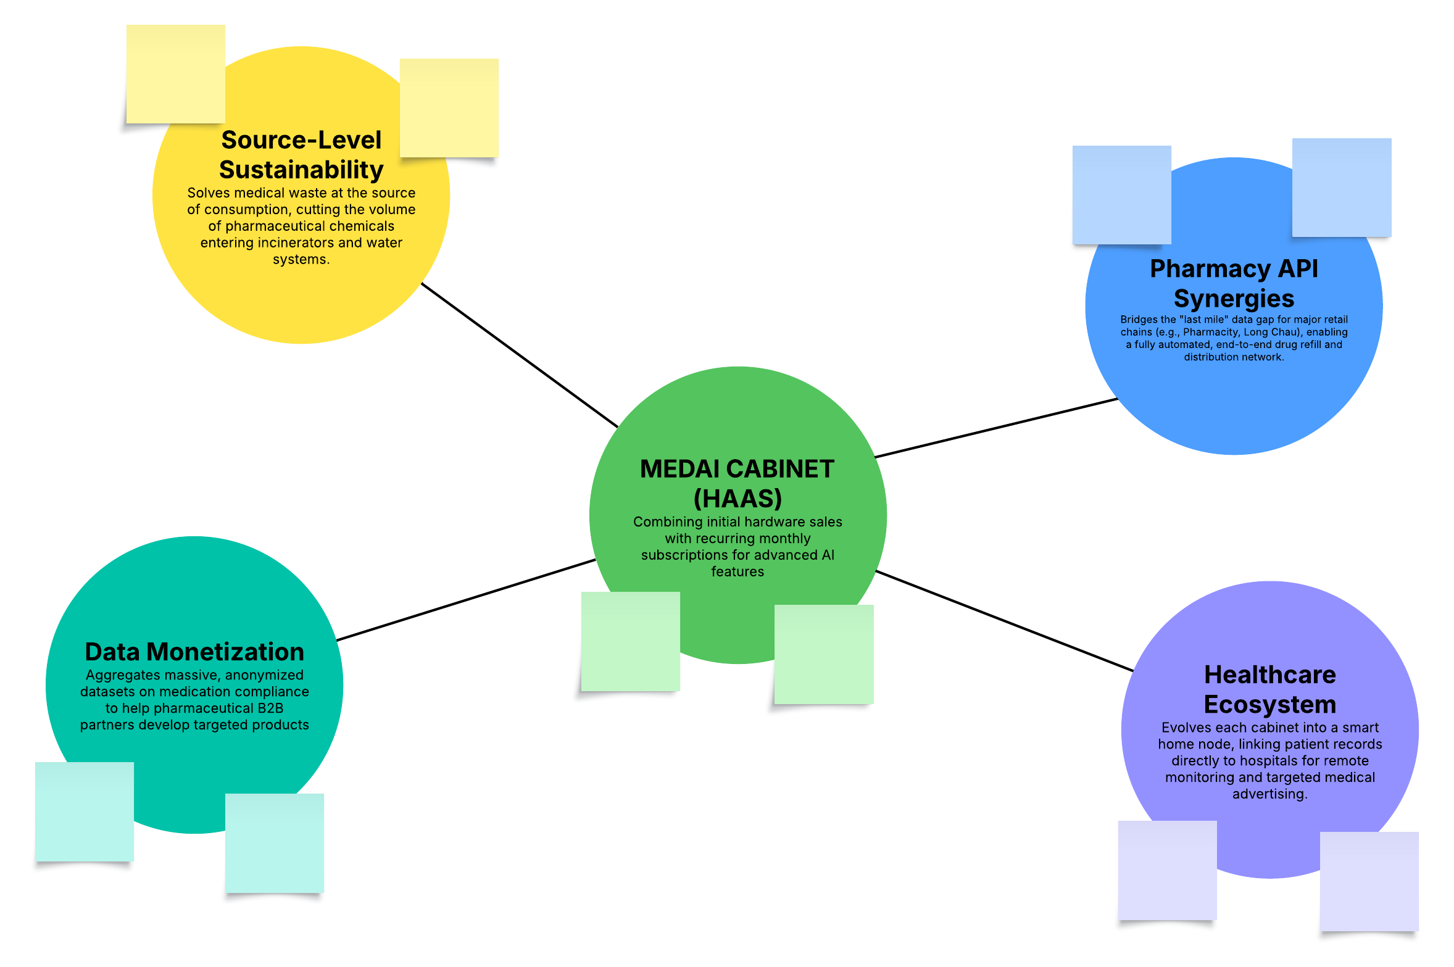
Figure 5: MEDIA Cabinet Ecosystem (HaaS)

6. Implementation Plan
Technology Development Track
Phase (Timeline) | Key Milestone | Technical Focus
Phase 1 (Month 1-3) | MVP Prototype | Assemble hardware (ESP32, sensors) & Train core edge AI (YOLOv8, OCR).
Phase 2 (Month 4-7) | Beta System Ready | Develop Mobile App Dashboard, integrate AI Triage logic & conduct fail-safe stress tests.
Phase 3 (Month 8-12) | Ecosystem Scale | Optimize Cloud infrastructure & deploy direct API integration with pharmacy retail chains.
Business & Market Track
Phase (Timeline) | Key Milestone | Business Focus
Phase 1 (Month 1-3) | Market Validation | Conduct user interviews, finalize HaaS pricing structure & pitch for seed funding.
Phase 2 (Month 4-7) | Beta Partnerships | Deploy pilot testing in local clinics/nursing homes & gather user experience (UX) feedback.
Phase 3 (Month 8-12) | Commercial Launch | Execute official rollout & initiate B2B Data Monetization negotiations with pharma partners.

